B.24

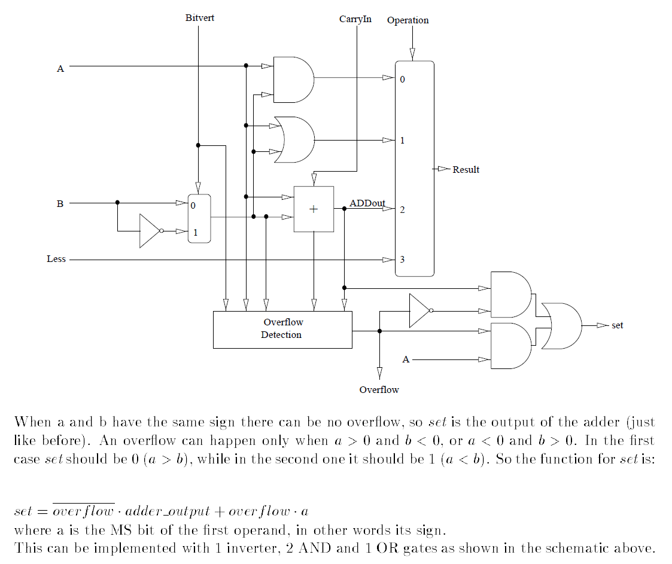

B.26

C4 = G3,0 + C0 P3,0

C8 = G7,4 + G3,0 P7,4 + C0 P3,0 P7,4

**C12** = G11,8 + G7,4 P11,8 + G3,0 P7,4 P11,8 + C0 P3,0 P7,4 P11,8

C16 = G15,12 + G11,8 P15,12 + G7,4 P11,8 P15,12 + G3,0 P7,4 P11,8 P15,12 + C0 P3,0 P7,4 P11,8 P15,12

B.27

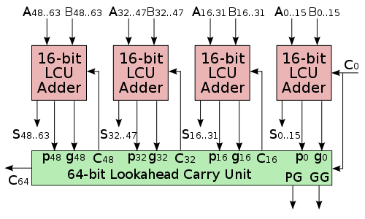

C16 = G15,0 + C0 P15,0

C32 = G31,16 + G15,0 P31,16 + C0 P15,0 P31,16

C48 = G47,32 + G31,16 P47,32 + G15,0 P31,16 P47,32 + C0 P15,0 P31,16 P47,32

C64 = G63,48 + G47,32 P63,48 + G31,16 P47,32 P63,48 + G15,0 P31,16 P47,32 P63,48 + C0 P15,0 P31,16 P47,32 P63,48

B.30   
A. Ripple adder only: 64*2T=128T

B. Ripple carry of 4-bit groups that use carry lookahead: 3T+2T*(16-1)=33T

C. Ripple carry of 16-bit groups with CLA: 3T*(64/16)=12T

D. HCLA

Although the diagram below is for 4 bit HCLA, the principles are the same.

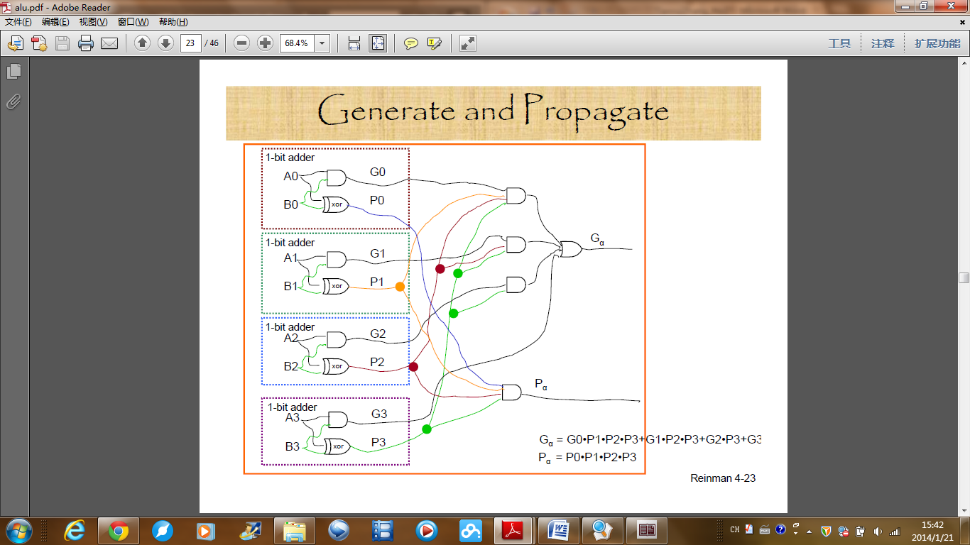

$$c64=G_{63,48}+\left(P_{63,48}*{G_{47,32})+(P_{63,48}*P_{47,32}*G}_{31,16}\right)+\left({P_{63,48}*P}_{47,32}*P_{31,16}*G_{15,0}\right)+\left({{P_{63,48}*P}_{47,32}*P}_{31,16}*P_{15,0}*c0\right)$$

It takes additional 2 levels of gates to produce the final results. Therefore, in total, we will have delay 5T.